Practical - 12
Practical Title: Event Management CRUD with Poster Upload and File Validation

Develop event management functionality for admin users. Admin can add, view, update, delete, and upload event posters with file type and file size validation.

Theory
1. Are add, update, and delete functionalities implemented correctly?
- Add: New records are added successfully and stored in the database.
- Update: Existing records are updated correctly with the modified details.
- Delete: Selected records are deleted successfully from the database.
2. Is the UI linked with the database correctly?
- Yes, the UI is correctly connected to the database.
- Data is successfully stored, retrieved, updated, and deleted through the UI.
- The UI displays database records accurately.
3. Are poster uploads validated for type and size?
- Yes, poster uploads are validated for file type (e.g., JPG, PNG) and file size.
- Invalid file formats and files exceeding the size limit are rejected.
- Error messages are displayed to guide the user.
4. Are success and failure messages displayed?
- Success message is displayed when the operation is completed successfully.
- Failure message is displayed when an error occurs or the operation fails.
- These messages help users understand the status of their actions.
Implementation/Output/Result

My learning codes: https://drive.google.com/file/d/1CPP3uUq3gdKZxC3pFB7iheZVU7FCImSx/view?usp=drive_link

Evidence of Work (Screenshots)
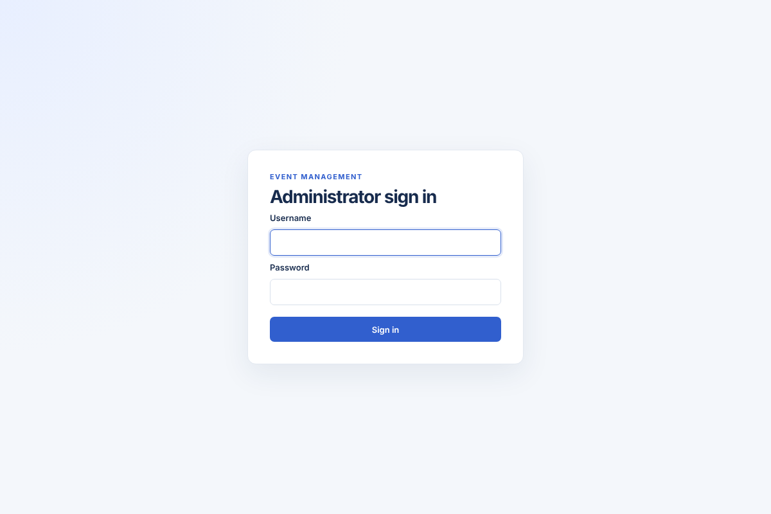
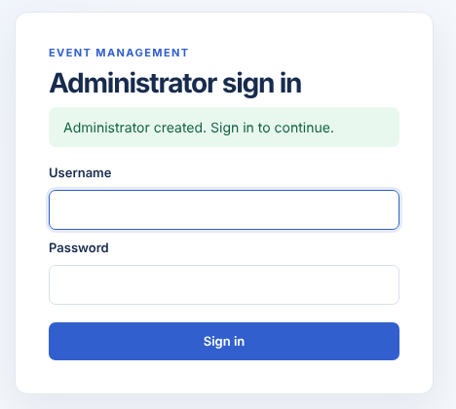
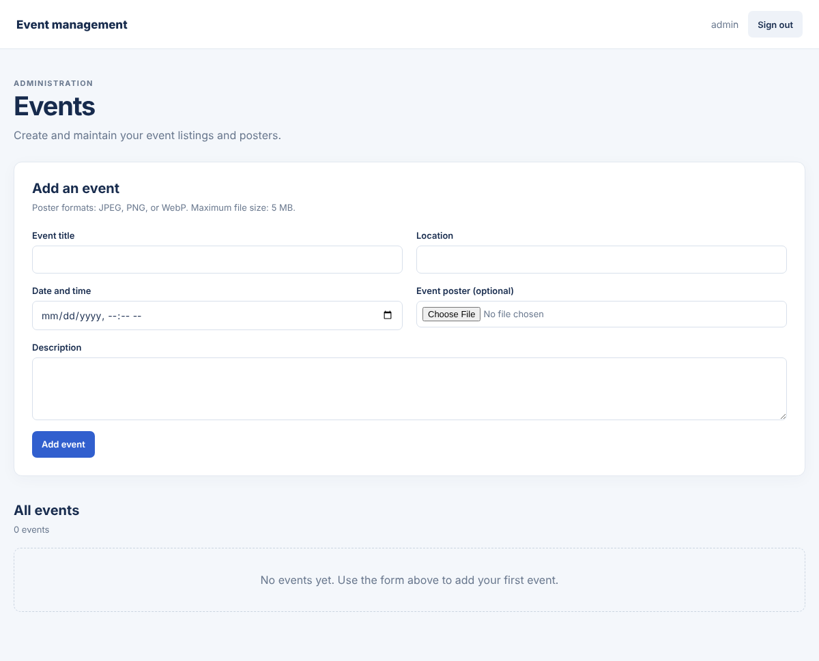

GitHub Repository Link:
Khushi-Thakor2007/Student-Hub-Portal

Challenges Faced:
- Implementing CRUD operations (Add, View, Update, Delete) correctly.
- Connecting the user interface with the database.
- Validating poster file types and file sizes during upload.
- Displaying appropriate success and error messages.

Learning Outcomes:
- Learned to implement CRUD operations for event management.
- Gained knowledge of database connectivity and data handling.
- Learned to upload posters with file type and size validation.
- Understood how to handle errors and display user-friendly messages.

Faculty Remarks:

